

Project Report



GROUP MEMBERS

1. M. TALHA KHAN
2. SOHAIB BASHIR
3. M.FARHAD

CONTENTS

……………………Introduction…………………….

Certificate Of Completion 4

**1. Definition of the problem** 6

**2. Requirement Analysis** 7

**3. Project Plan** 8

**4. E-R Diagram** 9

**5. Algorithms** 10

**6. GUI Standard Documents** 13

**6.1Administrator Activities** 13

**1.Php.ini File** 20

**2.Sendmail.ini File** 21

**6.2 Agent Activities** 25

**7. Interface Design Documents** 29

**8. Task Sheet** 34

**9. Source Code** 36

**10. Unit Testing Check List** 42

**11. Final Check List** 43



# Certificate Of Completion

This is to certify that

Mr. Talha

Mr. Sohaib

Mr. Farhad

Has Successfully Designed and Developed

“SOUND”

Date of issue 12 January 2023

Introduction

Music and Video’s are the most common source of entertainment today.

SOUND Group wants to host a WEBSITE for Entertainment. Company is looking on hosting new and old Video’s and Songs in both REGIONAL and ENGLISH language.

WEBSITE should have proper menu structure and Music and Video should be arranged as per ALBUM, ARTIST, YEAR, GENRE, LANGUAGE etc.

Users should have option of reviewing and rating the Music and Video’s available.

Home Page should have information about the site and a section for latest music and video with 5-5 listing in each.

# 1.Definition of the problem

Music and Video’s are the most common source of entertainment today.

SOUND Group wants to host a WEBSITE for Entertainment. Company is looking on hosting new and old Video’s and Songs in both REGIONAL and ENGLISH language.

WEBSITE should have proper menu structure and Music and Video should be arranged as per ALBUM, ARTIST, YEAR, GENRE, LANGUAGE etc. Users should have option of reviewing and rating the Music and Video’s available.

Home Page should have information about the site and a section for latest music and video with 5-5 listing in each.

# 2.Requirement Analysis

The Software is to be created based on the following requirements:

Website will host information about songs and videos with images and description and “New” image/icon should flash along with the new additions to Music and Video’s.

The website will have three users/roles:

1. Administrator
2. USER

The Administrator should be able to do the following:

1. Add Music files with information.
2. Add Video files with information.
3. Create Categories viz. YEAR, ARTIST, ALBUM etc.
4. Delete Music files
5. Delete Video files.
6. Create/Manage Users/Logins
7. Manage information/details on the WEBSITE

The USER should be able to do the following:

1. Register/Create Account [USERID should be unique].
2. Search for MUSIC/Video based on Name, ARTIST, YEAR, ALBUM etc.
3. ADD/Modify Reviews
4. ADD/Modify Ratings

Note: Name, Address, Phone Numbers, Email-ids should be mandatory to be provided. Proper Validations should be applied on all Data Fields.

Project should be submitted along with proper documentation and Database Backup.

# 5.Algorithms

The database algorithm structure of different tables is given in the following sections:

**Table: latest video**

|  |  |  |
| --- | --- | --- |
| **Field Name** | **Data Type** | **Description** |
| Id | Integer | Stores the unique ID of the  Users table (auto-generated unique identifier of this table) |
| Cover | Varchar | Stores the thumbnail of the video |
| Title | Varchar | Stores the name of the video |
| video file | Varchar | Stores the path of the video |

**Table: admin login**

|  |  |  |
| --- | --- | --- |
| **Field Name** | **Data Type** | **Description** |
| ID | Integer | Stores the unique ID of the  Branches table (auto-generated unique identifier of this table) |
| Name | Varchar | Stores the name of admin accounts |

|  |  |  |
| --- | --- | --- |
| Email | Varchar | Stores the email of admin accounts |
| Password | Varchar | Stores the password of admin accounts |

**Table: latest audio**

|  |  |  |
| --- | --- | --- |
| **Field Name** | **Data Type** | **Description** |
| Id | Integer | Stores the unique ID of the  Couriers table (auto-generated unique identifier of this table) |
| Image | Varchar | Stores the path of image of music title |
| name | Varchar | Stores the name of song |
| Genre | Varchar | Stores the category of regarding file |
| Year | Varchar | Stores the release year of regarding song |
| Artist | Varchar | Stores the name of the artist |
| language | Varchar | Stores the language of the song |
| Album Name | Varchar | Stores the name of songs album |
| Album Cover | Varchar | Stores the path of the album cover image |
| Audio File | Varchar | Stores the path of video file |

**Table: Company**

|  |  |  |
| --- | --- | --- |
| **Field Name** | **Data Type** | **Description** |
| Id | Integer | Stores the unique ID of the  Company table (auto-generated unique identifier of this table) |
| Address | Varchar | Stores the address of the company |
| MF Timing | Varchar | Stores the M to F timing of the company |
| S Timing | Varchar | Stores the specific timing of the company |
| Email | Varchar | Stores the email id of the company |
| Phone | Varchar | Stores the phone no of the company |
| Button Text | Varchar | Stores the contact button text of the company |

**Table: Contact**

|  |  |  |
| --- | --- | --- |
| **Field Name** | **Data Type** | **Description** |
| Id | Integer | Stores the unique ID of the  Contact table (auto-generated unique identifier of this table) |
| Name | Varchar | Stores the name of user |
| Email | Varchar | Stores the email id of the user |
| Message | Varchar | Stores the message of the user |

**Table: Subscription**

|  |  |  |
| --- | --- | --- |
| **Field Name** | **Data Type** | **Description** |
| Id | Integer | Stores the unique ID of the  Subscription table  (autogenerated unique identifier of this table) |
| Email | Varchar | Stores the subscription email id of the customer |

# 6.GUI Standard Documents

GUI Standard Document includes all the Administrator and Agent’s dashboard activities.

### 6.1Administrator Activities

Admin can view all data and control data through following admin panel.

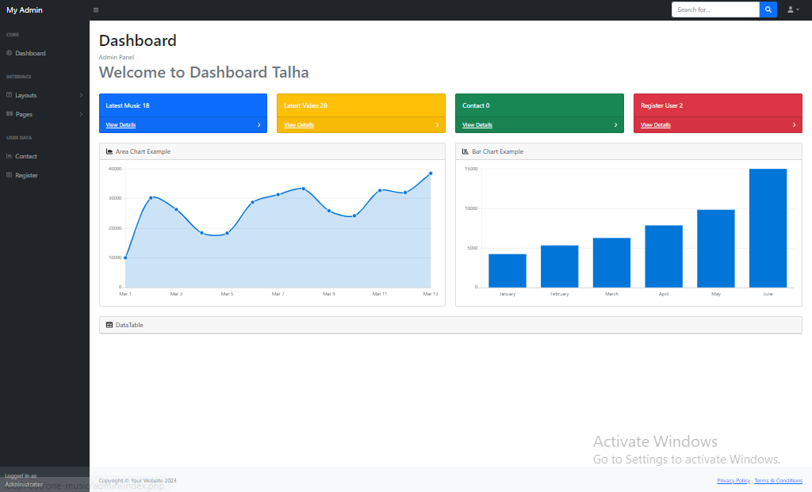

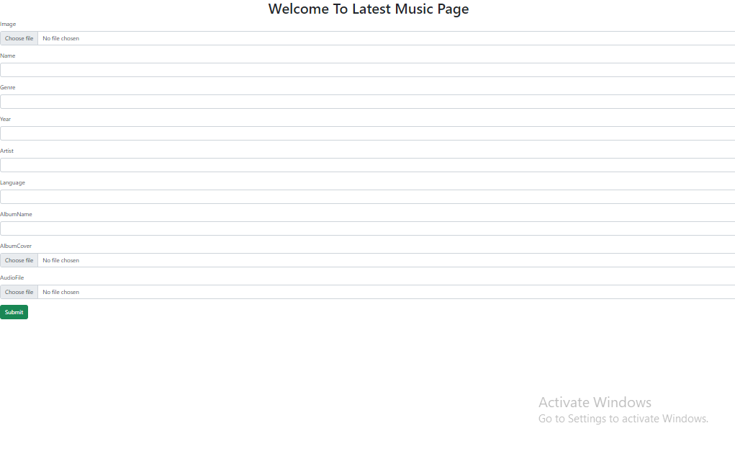

* Admin can also update data and information about audio.

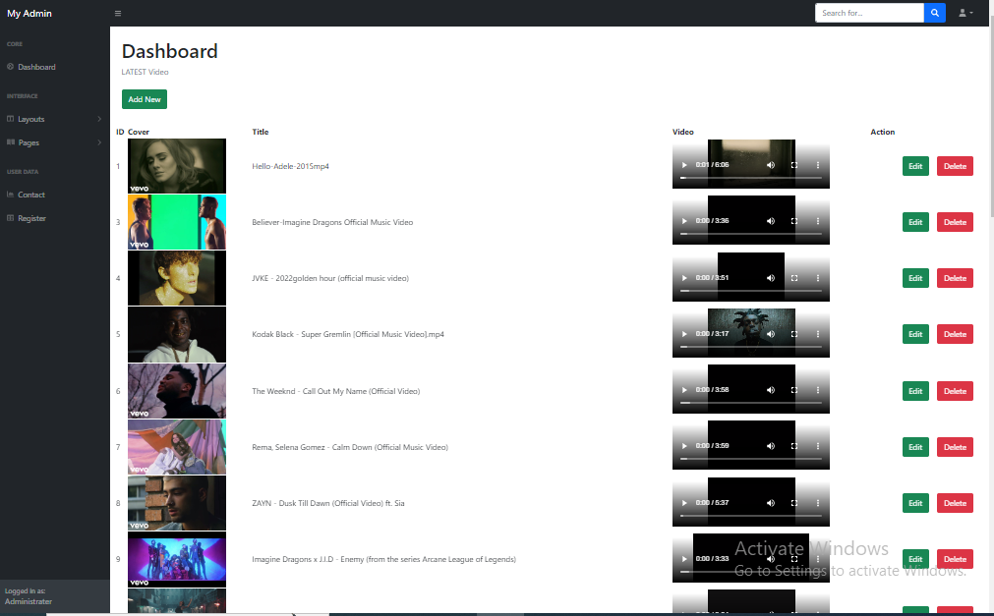

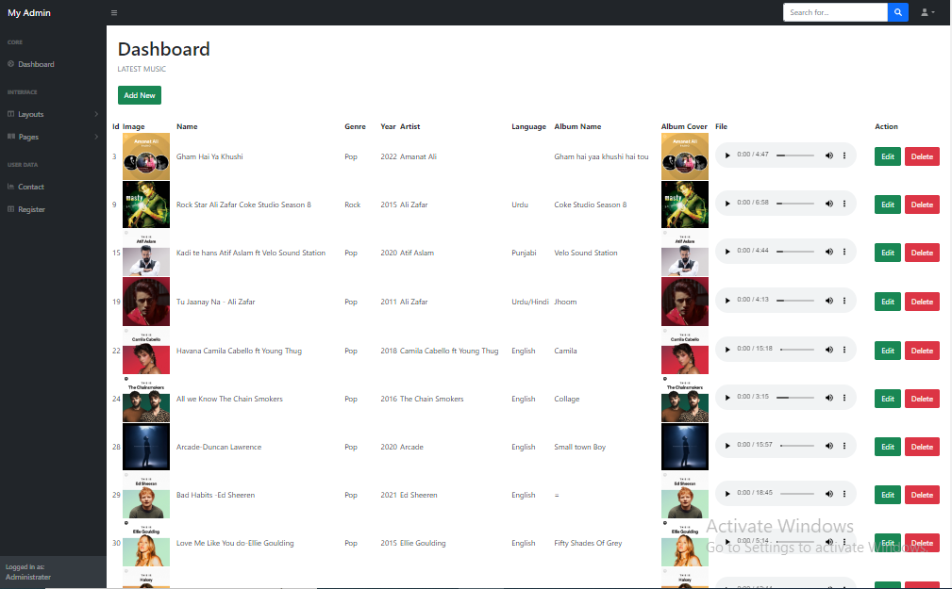

After this there is also table about administer login

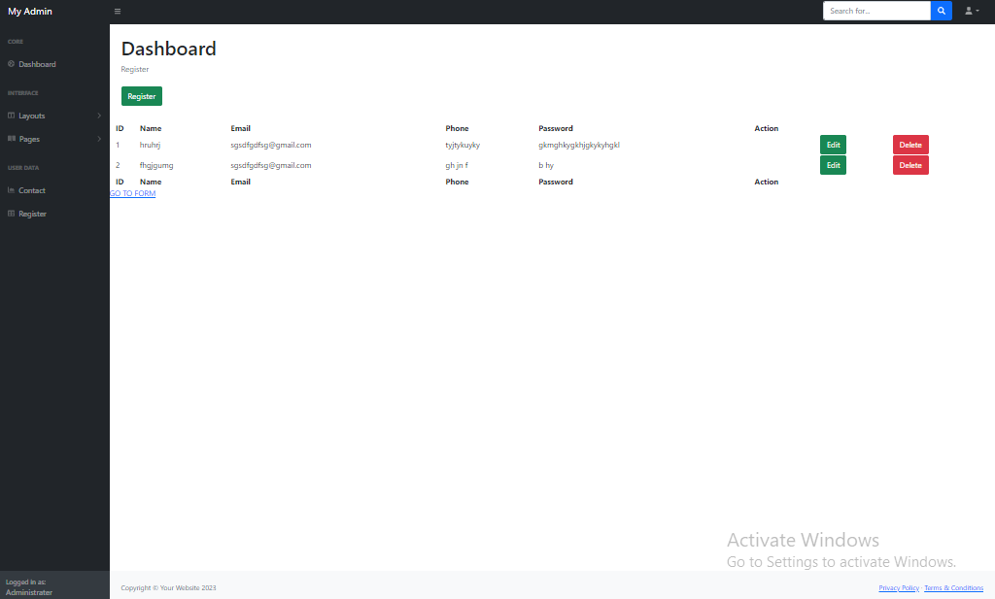

There is a navigation menu about website.



The footer also contains complete menu of website.



Here is the front index page of the web app where you can see complete menu of the website with transition c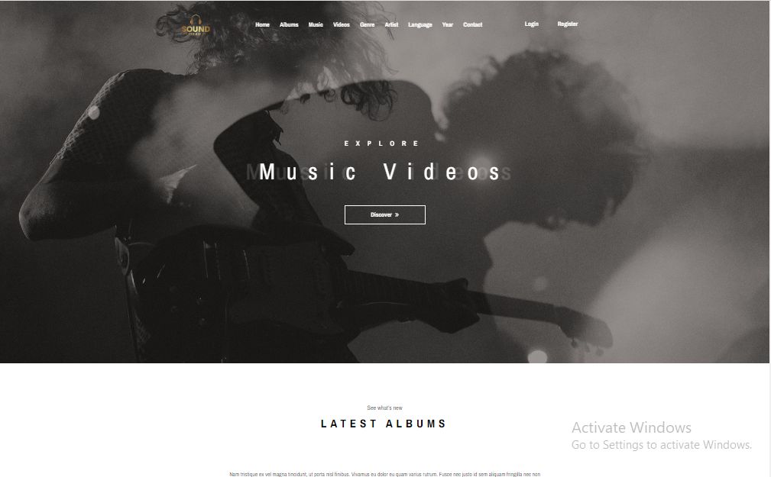

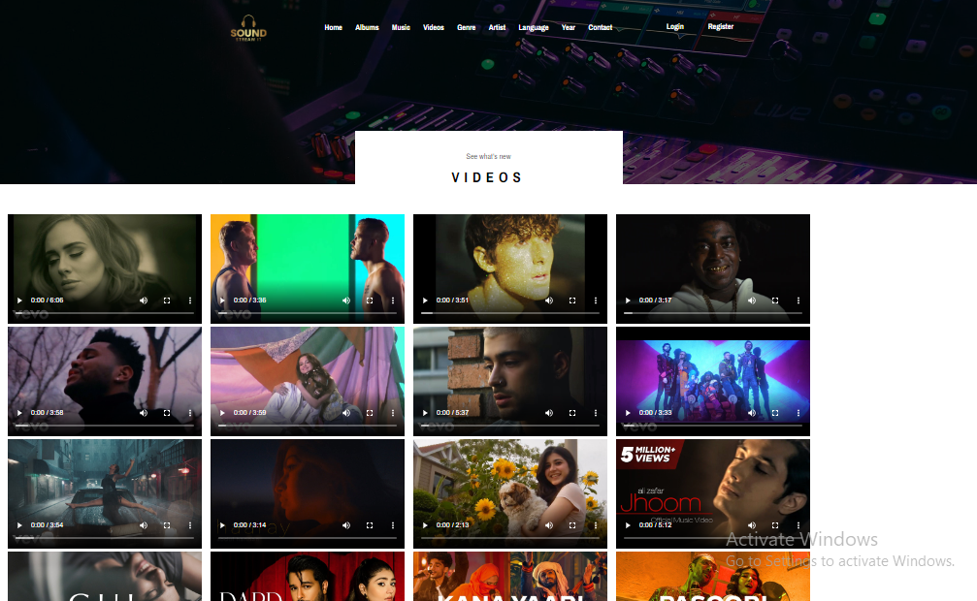Sending Multimedia video files from backend to front-end web application by using php.

# 7.Admin

In the end admin and agent can logout by clicking on their profile at top right corner, if they have done with their actions on the database.

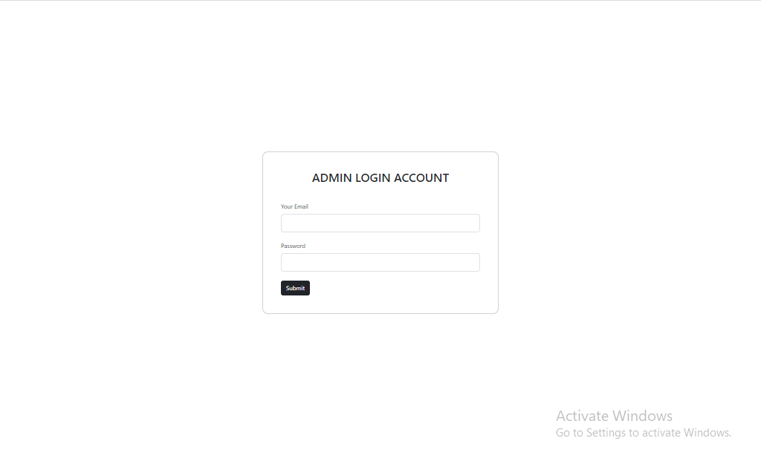

* 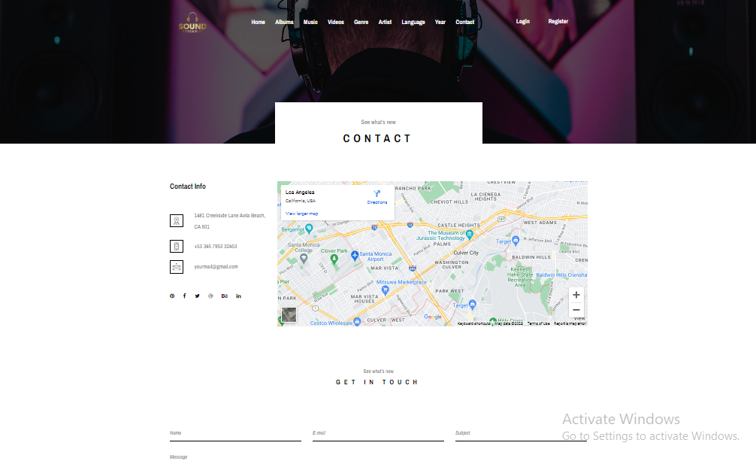Find Us Section

# 8.Task Sheet

|  |  |  |
| --- | --- | --- |
| **Date** | **Task** | **Resource** |
| 12 Jan 2023-15 Jan 2023 | User Interface Design | Muhammad Talha |
| 14 Jan 2023 -19 Jan 2023 | Back-End-Content Uploading | Muhammad Talha |
| 20 Jan 2023 -24 Jan 2023 | Admin Panel | Sohaib |

# 9.Source Code

* Edit

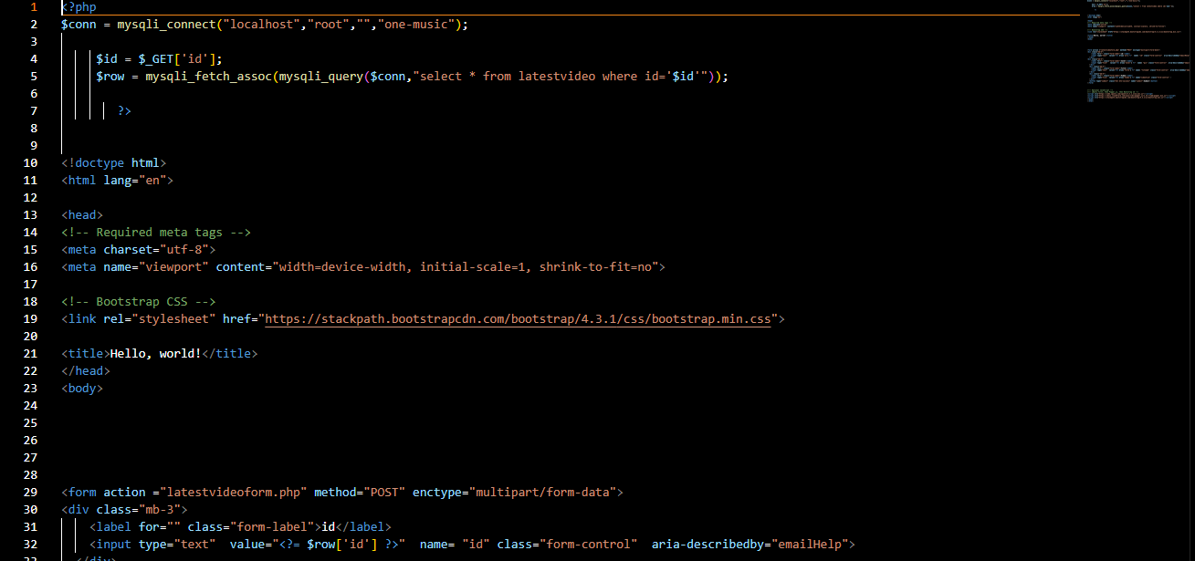

* Delete

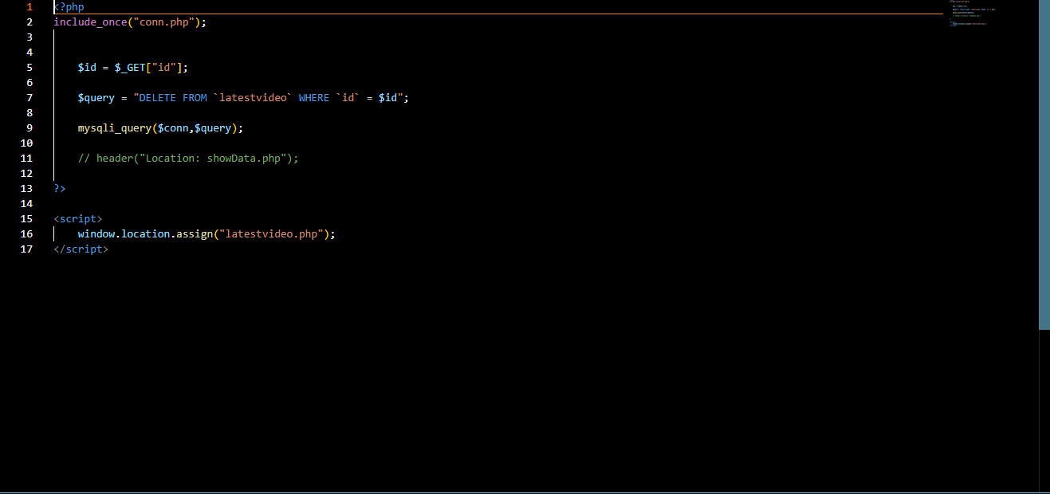

* Update

.

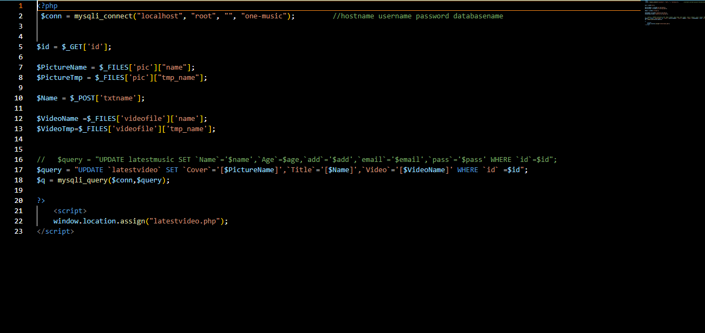

* Uploading Multimedia files in database and admin panel.

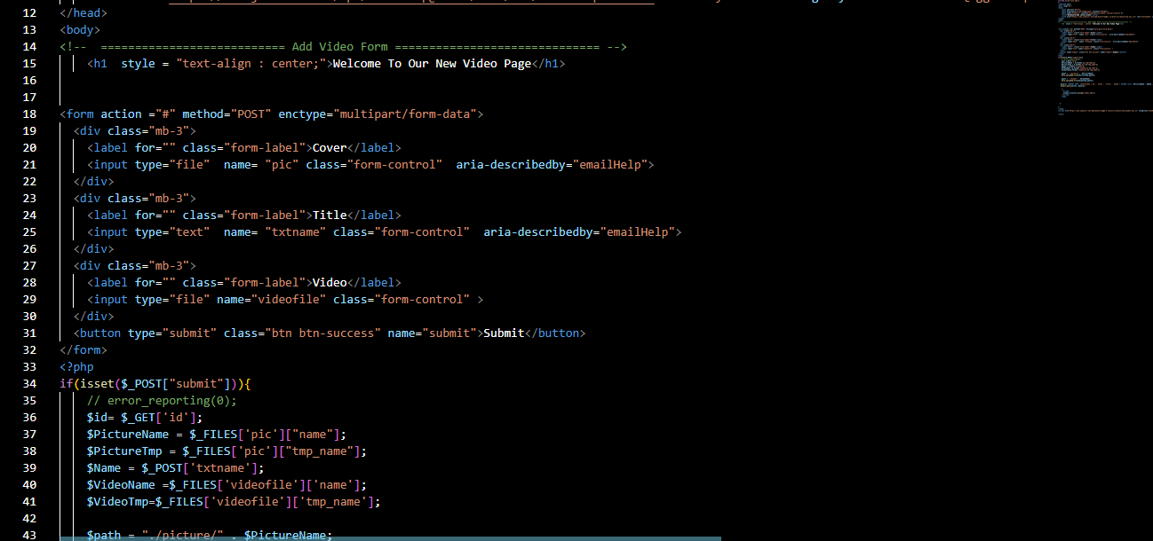

# 10.Unit Testing Check List

|  |  |
| --- | --- |
| **Sound Management Website** | |
| Company Name | Sound |
| Admin Login | Successfully Working |
| Home Page Menu | Successfully Working |
| Music Videos | Successfully Working |
| Regional Music Videos | Successfully Working |
| international Music Videos | Successfully Working |
| Edit , Delete and Update | Successfully Working |
| Regional Music Videos | Successfully Working |

# 11.Final Check List

All the requirements specified by customer has been checked.